Google Maps Store Locator Software Requirements

# Goals

* Build a Google Maps store locator to allow users find stores near them

# User Stories

As a <User>, I want <Goal> so that <some reason>

TASK: Complete User Story for seeing stores around a user’s zip code

As a <User>, I want to be able to input my local zip code and see stores available.

As a <User>, I want to be able to see stores in 2 miles radius near so that i can pick the closest to me.

As a <User>, I want to be able to see all the locations of the stores on map.

As a <User>, I want to be able to click on store and have a show up info about it.

As a <User>, I want to click directions to get directions to the store.

As a <User>, I want to click on the phone number to call a store.

# Flow Diagram(Swimlane)

Shows who does what in the process (Example)

TASK: Complete Swimlane for seeing the stores around a user’s zip code

# Business Requirements

General requirements of what the business needs to do to stay in business

TASK: Complete Business Requirements for Home Page

* Allow a user to find the stores near zip code
* Show the user a list of stores 2 miles within the zip code location
* Allow a user to view more information about the store
* Allow a user to make directions from their location
* Allow a user to call directly to the store
* Show the following info on the store:
  + Address
  + Phone number
  + Open status
  + Store name

# Technical Requirements

* Use Google Maps JavaScript API
  + <https://developers.google.com/maps/documentation/javascript/tutorial>
* Use NodeJS for API
* Use MongoDB Atlas for Database
* Use Google Maps Geocoder to geocode users zip code
  + [https://developers.google.com/maps/documentation/geocoding/start](https://developers.google.com/maps/documentation/geocoding/start?)
* API Endpoints
  + GET: stores/
    - Return a list of stores;

- GET: stores?zip=<zip code>

- to return a list of stores within zip code

- POST: stores/

-Save list of stores in DB.

### 

### Swim Lane Diagram Example

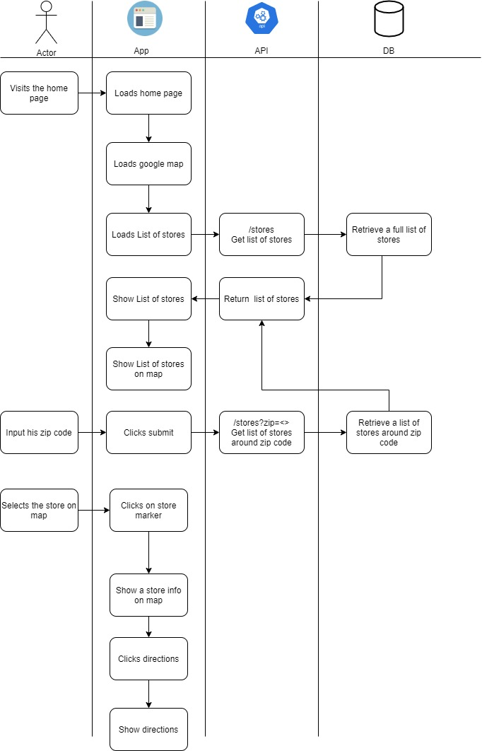

WIREFRAME

